**Assignment 3.1**

1. How many vowels are there in the names of USA States?

States<- rownames(USArrests)

vowels<-c("a","e","i","o","u")

num_vowels = vector(mode = "integer", length = 5)

for (i in seq_along(vowels)) {

num_aux = str_count(tolower(States), vowels[i])

num_vowels[i] = sum(num_aux)

}

names(num_vowels) = vowels

num_vowels

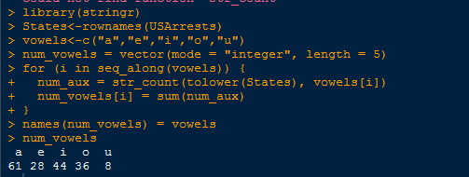

2. Visualize the vowels distribution.

barplot(num_vowels, main = "Number of vowels in USA States names",

border = NA, ylim = c(0, 80))

